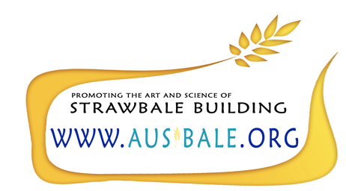

Dear Strawbaler,

Ausbale, the Australasian Strawbale Association, will be hosting a national strawbale conference in September 2018. While we would love to have each and every one of you come share your work and projects with us, we are a long, expensive, impractical distance from most of you. Thus, we would like to ask you to be a part of our “World Strawbale Wrapup.”

Ausbale will compile a video of contributions from around the world showcasing the inspiring work that is happening away from our shores. If you would like to be a part of this venture, please send us a short video telling us your story. What are you doing? Obstacles? Successes? Failures? Challenges? Inspiration? Beautiful buildings?

I was hugely inspired to be able to hear, first-hand, of the amazing projects taking place around the world when I attended the international conference in New Zealand in 2016. We would like our local attendees to have a similar opportunity.

As a thank you for your participation, we will send you a copy of the compilation “World Strawbale Wrapup” video that is created. We intend it to be inspiring and entertaining.

Please contact Enga (enga@thelokeys.net) for more details and to express an interest in participating. Deadline for submissions: April 2018

